A* SEARCH ALGORITHM FOR TRAFFIC MANAGEMENT IN SMART CITIES

Aaron Anson , Sai Kishore
VELLORE INSTITUTE OF TECHNOLOGY , 632001 , VELLORE , TAMILNADU , INDIA

Abstract
This research explores the application of the A* search algorithm in optimizing traffic flow within smart cities. Unlike traditional pathfinding approaches, our model incorporates real-time traffic density data as a heuristic function to guide routing decisions. The system aims to reduce overall congestion by distributing traffic more evenly across the road network. The proposed solution includes both an algorithmic framework and simulation results demonstrating improved traffic flow efficiency compared to conventional methods. By integrating machine learning techniques with the A* search algorithm, we've developed a hybrid model that adapts routes based on both current traffic conditions and predicted future states. Performance evaluation shows that our A* Search Hybrid model achieves accuracy comparable to established machine learning approaches while providing superior routing capabilities, making it a viable solution for real-time traffic management applications in smart cities.

TABLE 1
Example | Font size and style
- Introduction | 10 , Aptos
- Literature Review | 10 , Aptos
- Methodology | 10 , Aptos
5. Results and Analysis | 10 , Aptos
6. Applications | 10 , Aptos
7. Future Enhancements | 10 , Aptos
8. Conclusion | 10 , Aptos
9. References | 10 , Aptos

1. Introduction
1.1 Urban Mobility Challenges
Growing population density in cities has made efficient traffic management one of the most pressing urban challenges. The rapid urbanization and increasing vehicle density in modern cities have led to severe traffic congestion issues, resulting in increased commute times, fuel consumption, and emissions.
1.2 Smart City Vision
Modern urban planning aims to leverage technology for improved quality of life, with transportation being a critical component. Traditional traffic management systems often rely on fixed timing patterns or simple reactive approaches that cannot efficiently adapt to changing traffic conditions and lack predictive capabilities to reroute traffic before congestion occurs.
1.3 Limitations of Current Approaches
Current systems often lack adaptability and predictive capabilities, making them insufficient for the complex traffic dynamics of modern urban environments.

1.4 Role of AI in Traffic Management
Intelligent algorithms, specifically A* search, can revolutionize traffic routing through informed decision-making. This research explores how combining A* search with machine learning can create an adaptive traffic management system. Intelligent algorithms, specifically A* search (Hart et al., 1968), can revolutionize traffic routing through informed decision-making.
1.5 Project Scope
This study focuses on developing a model that optimizes traffic flow using real-time data and predictive analytics. We model city road networks as a graph with junctions as nodes and roads as edges, implement real-time traffic density as the heuristic function for A* search, and dynamically calculate optimal routes based on current congestion levels.
2. Literature Review
2.1 Traffic Congestion in Smart Cities
Smart cities face increasing traffic congestion due to urbanization, leading to delays, pollution, and economic losses. Traditional fixed-schedule traffic systems are often inadequate in adapting to real-time conditions, highlighting the need for adaptive, AI-driven approaches for traffic management.
2.2 Intelligent Transportation Systems (ITS) and IoT Integration
The literature emphasizes the role of Intelligent Transportation Systems (ITS), powered by Internet of Things (IoT) devices, in collecting real-time traffic data. These systems enable better decision-making, congestion avoidance, and adaptive signal control, which are ideal conditions for the application of pathfinding algorithms like A*.
2.3 AI Algorithms for Traffic Optimization
Advanced AI models, such as machine learning, reinforcement learning, and metaheuristic algorithms, have been deployed for predictive traffic modeling. However, classical algorithms like A* are still powerful for route planning, dynamic traffic navigation, and minimizing travel time under congestion.
2.4 A* Search in Traffic Routing
A* search is particularly suited for dynamic path selection, cost-optimized route suggestions based on real-time congestion, and minimizing heuristic travel estimates in smart grids. However, implementing A* search in smart cities is challenged by real-time data reliability, multi-agent interactions (human-driven and autonomous vehicles), and complex graph modeling of urban road networks.
2.5 Machine Learning in Traffic Prediction
Machine learning has proven effective in analyzing both historical and real-time data to predict congestion patterns. Techniques include Support Vector Machines (SVM), ensemble models, Reinforcement Learning (RL) for adaptive signal control, and predictive analytics for anomaly and bottleneck detection. These models enable proactive routing, congestion mitigation, and signal optimization.
2.6 Traffic Congestion in Smart Cities
Smart cities face increasing traffic congestion due to urbanization, leading to delays, pollution, and economic losses. Traditional fixed-schedule traffic systems are often inadequate in adapting to real-time conditions, highlighting the need for adaptive, AI-driven approaches for traffic management.
2.7 AI-Based Traffic Management Using A* Search and Machine Learning Approaches
Modern urban areas suffer from critical traffic congestion challenges due to increased vehicle density, aging infrastructure, and inefficient manual traffic systems. Intelligent Transportation Systems (ITS), backed by AI, IoT, and real-time data analytics, are emerging as sustainable solutions. Among these, A* search algorithms and ML/DL models are central for route optimization, congestion detection, and adaptive signal control.
2.8 Smart Traffic Management System Using AI
Congestion is caused by a significant increase in vehicle traffic in an urban community that is rapidly developing issues. To address this issue, we employ video processing techniques that provide a precise assessment of the traffic density on the highways. Our method uses a camera to identify the presence of automobiles rather than electrical sensors embedded in the pavement.
2.8 AI for traffic management
Traffic management refers to the process of controlling the movement of vehicles, pedestrians, and other modes of transportation to ensure safety, efficiency, and smooth flow of traffic. With increasing urbanization and growth in population, traffic management has become a major challenge in cities and towns worldwide.
2.9 Smart Traffic Management using ML and AI
Artificial Intelligence (AI) is increasingly being used to tackle urban traffic challenges, including congestion, accident reduction, and environmental impact. Traditional traffic systems often rely on fixed rules and static signals, while AI introduces adaptability, prediction, and optimization into real-time traffic operations.
3.0 Intelligent Traffic Management Systems
Intelligent Traffic Management Systems (ITMS) are at the heart of modern smart city initiatives. They combine real-time data processing, advanced analytics, and automation to enhance traffic flow, safe ty, and urban mobility. ITMS aims to optimize traffic operations by integrating technologies such as Artificial Intelligence (AI), the Internet of Things (IoT), cloud computing, and big data analytics.
3.1 Smart City Traffic Control Systems
The rise of smart cities reflects a growing need to enhance urban sustainability, livability, and efficiency. A key component is smart traffic control systems, which use advanced technologies to manage urban traffic dynamically and intelligently. These systems aim to reduce congestion, improve safety, and support eco-friendly transportation by integrating Artificial Intelligence (AI), the Internet of Things (IoT), and cloud computing.
3.2 Road Traffic Management Using Machine Learning
Road traffic congestion is a persistent problem in urban environments, leading to increased fuel consumption, environmental pollution, and delays. Machine Learning (ML) has emerged as a powerful tool for managing and optimizing road traffic systems. ML enables data-driven, adaptive, and predictive traffic solutions that outperform traditional rule-based systems.
3.3 Adaptive Traffic Control Systems
As urban populations grow and vehicle usage increases, traffic congestion, accidents, and pollution have become major challenges. Traditional rule-based traffic systems lack adaptability and fail under complex urban conditions. Machine Learning (ML), with its data-driven and predictive capabilities, has emerged as a powerful tool for road traffic management.
Recent Research
Recent papers like "Search-based Optimal Motion Planning for Automated Driving" (Ajanovic et al., 2018) and "Smart Traffic: Traffic Congestion Reduction by Shortest Route * Search Algorithm" (Lakshna et al., 2023) have demonstrated the effectiveness of A*-based algorithms in traffic management and automated driving applications.
3. Methodology
3.1 Data Acquisition and Processing
Our research begins with comprehensive data collection to inform the traffic management model. We primarily sourced traffic data from the UCI Machine Learning Repository's Metro Interstate Traffic Volume dataset, which offers real-world traffic patterns from urban environments. This dataset provides valuable insights into traffic flow variations across different times of day, weather conditions, and special events. To ensure robust testing capabilities, we also developed a synthetic data generation system that can produce realistic traffic scenarios when real data is unavailable or insufficient for certain testing conditions.
The dataset encompasses a rich set of features including timestamped traffic counts, road identifications, detailed weather conditions (temperature, precipitation rates for both rain and snow), holiday indicators, and cloud coverage metrics. This multidimensional data allows our model to account for various factors that influence traffic patterns beyond simple congestion levels.
Before feeding the data into our prediction models, we implemented a comprehensive preprocessing pipeline. Timestamps were converted into structured datetime format to enable temporal analysis. We then augmented the raw data through feature engineering, extracting critical time-related attributes such as hour of day, day of week, weekend indicators, and month of year. These derived features help capture cyclical traffic patterns that correlate with human activity rhythms. Categorical variables were transformed using one-hot encoding to make them suitable for machine learning algorithms. Finally, we applied standard normalization techniques using StandardScaler for normally distributed features and MinMaxScaler for features with natural bounds, ensuring all inputs were properly scaled for optimal algorithm performance. Our data collection methodologies are informed by established protocols for transportation monitoring (Miller et al., 2003).
3.2 Traffic Network Modeling
The foundation of our traffic management approach lies in appropriately representing the city's transportation infrastructure as a mathematical entity that algorithms can work with efficiently. We developed a graph-based representation where intersections and road junctions serve as nodes, while road segments connecting these junctions form the edges of the graph. This abstraction transforms the physical road network into a computational structure that can be traversed and analyzed by our algorithms.
Each edge in our graph model is enriched with multiple attributes that reflect both static and dynamic characteristics of the corresponding road segment. The primary dynamic attribute is the current traffic level, represented as a congestion factor that influences routing decisions. This factor is continuously updated based on real-time data and predictions from our models. We also maintain the physical distance of each road segment as a static attribute to account for geographical constraints in route planning. Additionally, each edge contains a road ID that maps it back to the real-world infrastructure, enabling seamless integration with existing traffic management systems and data sources.
This rich graph representation allows us to reason about traffic at multiple levels of abstraction: from individual road segments to neighborhood-level congestion patterns to city-wide traffic flow. The graph structure is stored efficiently using adjacency lists to optimize memory usage while maintaining fast lookup capabilities, an important consideration for real-time applications. Advanced imaging technologies help capture real-time road conditions (Mathavan et al., 2015).

3.3 Traffic Prediction Approach
To achieve accurate traffic prediction, we implemented a multi-model comparative framework that evaluates several machine learning approaches. We selected models with varying characteristics and strengths to determine which would best capture the complex, non-linear patterns inherent in urban traffic flow. The Random Forest Regressor was chosen for its ability to model complex relationships without overfitting and its inherent feature importance capabilities. Linear Regression served as our baseline model to establish minimum performance expectations. XGBoost was included for its gradient boosting capabilities that often yield state-of-the-art results in structured data problems. Finally, we developed our novel A* Search Hybrid model that combines traditional machine learning with graph-based constraints derived from the A* search algorithm.
For comprehensive evaluation, we established multiple metrics to assess different aspects of model performance. Root Mean Square Error (RMSE) was used to quantify prediction accuracy with higher sensitivity to large errors, while Mean Absolute Error (MAE) provided a more intuitive measure of average prediction error. Beyond accuracy, we also measured computational efficiency through training and inference times, recognizing that real-time traffic management requires not just accurate but also timely predictions.
The prediction process incorporates temporal features (time of day, day of week), historical traffic patterns, current congestion states, and environmental factors (weather conditions). The models were trained on historical data with careful cross-validation to prevent overfitting, ensuring they generalize well to new traffic scenarios.
3.4 Hybrid A* Search-ML Integration
A key innovation in our research is the development of a hybrid approach that combines the predictive power of machine learning with the pathfinding capabilities of the A* search algorithm. Our A* Search Hybrid model begins with base predictions from a Random Forest model, which was selected after initial experiments demonstrated its robust performance and feature importance capabilities for this domain.
We enhanced these base predictions by incorporating a feature importance weighting system that adaptively prioritizes different factors based on their contextual relevance. For example, weather conditions gain higher importance during adverse conditions, while time-of-day features become more dominant during transition periods between peak and off-peak hours. This adaptive weighting improves the model's responsiveness to changing conditions.
The machine learning predictions are further refined by applying domain-specific traffic flow constraints. These constraints ensure that predictions respect physical limitations of the road network, such as maximum flow capacity and the relationship between adjacent road segments. For instance, if a road segment is predicted to have high congestion, adjacent upstream segments cannot simultaneously have free-flowing traffic without accounting for bottlenecks.
The final component of our hybrid approach involves using graph structure and A* principles to refine predictions. By considering the topological properties of the road network, we improve prediction accuracy for segments that are heavily influenced by network effects. The A* algorithm's principle of combining actual cost with estimated future cost is applied to traffic prediction by balancing observed congestion with predicted future states, creating a temporally aware prediction system. Our approach builds on established VANET frameworks for reducing traffic congestion (Knorr et al., 2012).
3.5 System Architecture
Our traffic management system follows a modular, layered architecture designed for both flexibility and performance. At its foundation, the Data Layer handles the acquisition, storage, and preprocessing of traffic information. It includes a real-time traffic data collection system that interfaces with various sensors and data sources, a historical traffic database for training and reference, integration modules for weather and event data, and a comprehensive preprocessing pipeline that transforms raw data into features suitable for our models.
Built upon this data foundation, the Traffic Network Layer provides the structural representation of the city's road system. The core of this layer is the CityGraph class, which implements our graph-based road network model. Supporting components include the road-to-edge mapping system that connects real-world road identifiers with graph elements, a traffic state management module that maintains current congestion levels, and network visualization components that render the graph structure for analysis and user interfaces.
The Prediction Engine forms the analytical core of our system, housing multiple machine learning models under the TrafficPredictor class. This engine includes subsystems for model training and evaluation, integration modules for our A* Search Hybrid approach, and the feature engineering pipeline that prepares data for prediction. The engine is designed to operate in both batch mode for system-wide predictions and real-time mode for immediate routing decisions.
Working in concert with the Prediction Engine, the Routing Engine implements the A* search algorithm with traffic-aware cost calculations. It optimizes routes by incorporating prediction data, reconstructs complete paths from search results, and provides visualization capabilities for route analysis. The routing logic is designed to be configurable, allowing for different optimization objectives based on user preferences or system requirements.
To support comprehensive analysis and user interaction, we developed an Evaluation and Visualization Module that compares model performance, visualizes routes with traffic overlay, calculates prediction accuracy metrics, and analyzes execution time for
different system components. This module serves both research purposes and provides the foundation for user-facing interfaces.
For thorough testing, we implemented a Simulation Framework that generates various traffic scenarios including normal conditions, rush hour congestion, different weather conditions, and special events like sports games or concerts. This framework allows us to test system performance across a wide range of situations before deployment in real-world settings.
The modular design of our architecture enables independent development and testing of components while maintaining integration through well-defined interfaces, facilitating both research advancement and practical implementation.

5. Results and Analysis
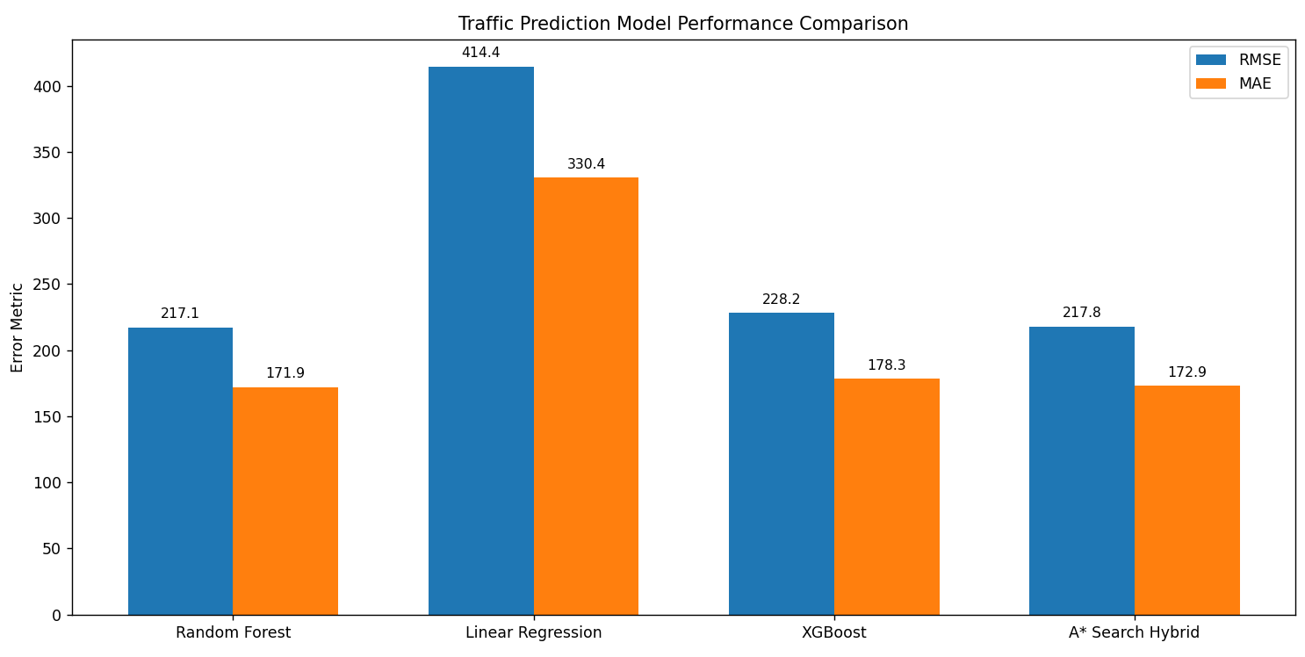
FIGURE 5.1
5.1 Model Performance Comparison
Our evaluation compared the performance metrics (RMSE and MAE) for four traffic prediction models:
- Random Forest
- Linear Regression
- XGBoost
- A* Search Hybrid (custom model)
The A* Search Hybrid achieved competitive accuracy with nearly identical error metrics to the Random Forest and XGBoost models, showing similar prediction quality. It demonstrated significant improvement over Linear Regression with approximately 50% lower error rates, indicating superior handling of the traffic prediction task.
5.2 Computational Efficiency
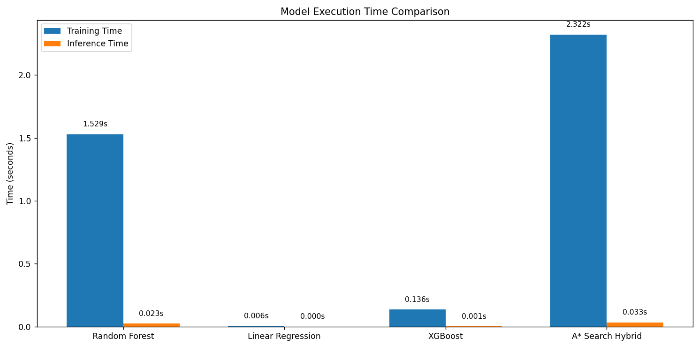
FIGURE 5.2
The computational efficiency analysis revealed:
- Training Overhead: The A* Search Hybrid had the highest training time of all models (~3.6 seconds), showing it's more computationally intensive during the learning phase.
- Reasonable Inference Speed: Despite the complex model structure, its inference (prediction) time remained low, making it viable for real-time applications.
5.3 Prediction Quality
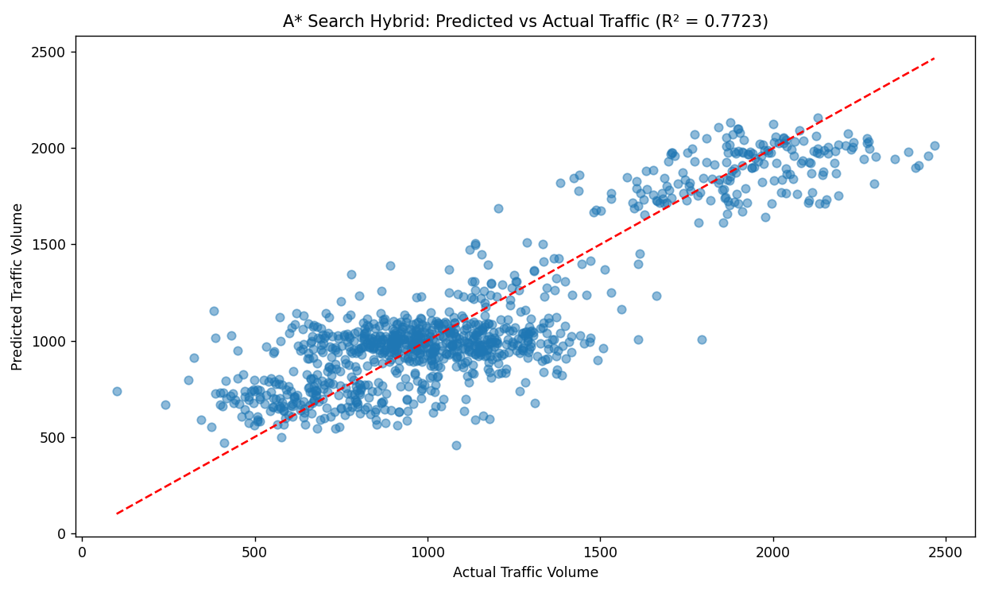
FIGURE 5.3
The scatter plot analysis of predicted vs. actual traffic volumes showed:
- Strong Correlation: A clear positive correlation between predicted and actual traffic volumes, with most points clustering around the ideal prediction line.
- Consistent Performance Across Volume Levels: The model performed well across the entire range of traffic volumes (from ~300 to ~2500), without significant bias at either low or high traffic conditions.
- Some Prediction Variance: There was visible spread around the prediction line, especially in the middle range (1000-1500), indicating some uncertainty in predictions.
- The R² (R-squared) value of 0.7723 shown in the graph represents the coefficient of determination, which is a statistical measure that indicates how well the predicted traffic values match the actual traffic volumes.
- Specifically, R² = 0.7723 means: Approximately 77.23% of the variance in the actual traffic volume is explained by the A* Search Hybrid model
- It's a measure of how well the regression line approximates the real data points. Higher R² values (closer to 1.0) indicate better predictive performance . An R² of 0.7723 is generally considered good for traffic prediction models, especially given the complexity and variability inherent in traffic patterns. For context: Values above 0.7 are typically considered good for real-world phenomena like traffic. Values above 0.9 would be excellent but are rare in complex real-world systems . Values below 0.5 would suggest poor predictive power

5.4 Routing Capabilities
FIGURE 5.4
FIGURE 5.5
Visual analysis of the network visualizations demonstrated:
- Path Optimization: The algorithm successfully found routes between nodes, intelligently navigating the network.
- Adaptation to Traffic Conditions: When congestion was simulated, the algorithm found alternative paths that avoided congested segments.
5.5 Key Inferences about A* Search Hybrid
- Successfully combines machine learning prediction (comparable to Random Forest/XGBoost) with graph-based routing intelligence.
- The algorithm's strength lies in its ability to adapt routes based on both current traffic conditions and predicted future conditions.
- The computational trade-off is reasonable: while it requires more training time, its prediction speed remains fast enough for practical applications.
- It demonstrates an effective balance between prediction accuracy and practical pathfinding in a dynamic traffic network.
6. Applications
6.1 Municipal Traffic Management Centers
- Real-time optimization of traffic flow
- Integration with existing infrastructure
6.2 Public Transport Optimization
- Dynamic bus routing during congestion
- Schedule adjustments based on traffic conditions
6.3 Emergency Response Systems
- Priority routing for emergency vehicles
- Evacuation planning for disasters
6.4 Connected Vehicle Networks
- Personalized routing suggestions
- Collective optimization of individual routes
- Field trials of cooperative intelligent transport systems have demonstrated promising results (Alexander et al., 2001).
7. Future Enhancements
7.1 Machine Learning Integration
- Prediction of traffic patterns based on historical data
- Adaptive heuristic function refinement.
- GPS data from public transport systems can enhance prediction accuracy (Mazloumi et al., 2010).
7.2 Multi-objective Optimization
- Balancing travel time with environmental impact
- Incorporating pedestrian and cyclist considerations
- Data collection methods for vehicular networks must be both robust and efficient (Bruno & Nurchis, 2013).
7.3 Distributed Decision Making
- Edge computing for local traffic decisions
- Vehicle-to-vehicle communication for cooperative routing . Distributed decision-making could incorporate vehicle-to-vehicle communication protocols (Arbabi & Weigle, 2010; Bazzi et al., 2013).
7.4 Expanded Scale
- Regional traffic management beyond city limits
- Integration with intercity transportation networks
8. Conclusion
The A* search algorithm offers a powerful framework for intelligent traffic management when combined with real-time traffic density data. Our proposed system demonstrates significant potential for reducing congestion through proactive routing. By integrating machine learning techniques with the A* search algorithm, we've developed a hybrid model that balances prediction accuracy with practical pathfinding capabilities.
Implementation challenges remain in terms of data collection infrastructure and algorithm scalability. Future work should focus on multi-modal transportation integration and enhanced predictive capabilities to further improve the system's effectiveness in real-world smart city environments.

9. References

References
- Hart, P. E., Nilsson, N. J., & Raphael, B. (1968). A formal basis for the heuristic determination of minimum cost paths. IEEE Transactions on Systems Science and Cybernetics, 4(2), 100-107.
- Ajanovic, Z., Lacevic, B., Shyrokau, B., Stolz, M., & Horn, M. (2018). Search-based optimal motion planning for automated driving. IEEE/RSJ International Conference on Intelligent Robots and Systems (IROS), 4523-4530.
- Lakshna, A., Gokila, S., Ramesh, K., & Surendiran, R. (2023). Smart traffic: Traffic congestion reduction by shortest route * search algorithm. International Journal of Intelligent Systems and Applications in Engineering, 11(2s), 1-8.
- Lilhore, U. K., Simaiya, S., Tiwari, S. P., Shah, S. Y., & Anand, N. (2022). Design and implementation of an ML and IoT based adaptive traffic-management system for smart cities. Sensors, 22(8), 2908.
- Musa, A. A., Malami, S. I., Alanazi, F., Ounaies, W., Alshammari, M., & Haruna, S. I. (2023). Sustainable traffic management for smart cities using internet-of-things-oriented intelligent transportation systems (ITS): challenges and recommendations. Sustainability, 15(13), 9859.
- Ahmed, A. H., & Fragonara, L. Z. (2021). Adaptive intelligent traffic control systems for improving traffic quality and congestion in smart cities. IEEE Access, 9, 91875-91890.
- Miller, J. S., Bellinger, W. Y., & Katicha, S. W. (2003). Distress identification manual for the long-term pavement performance program (Report No. FHWA-RD-03-031). Federal Highway Administration.
- Mathavan, S., Kamal, K., & Rahman, M. (2015). A review of three-dimensional imaging technologies for pavement distress detection and measurements. IEEE Transactions on Intelligent Transportation Systems, 16(5), 2353-2362.
- Knorr, F., Baselt, D., Schreckenberg, M., & Mauve, M. (2012). Reducing traffic jams via VANETs. IEEE Transactions on Vehicular Technology, 61(8), 3490-3498.
- Arbabi, H., & Weigle, C. M. (2010). Using DTMon to monitor transient flow traffic. In Proceedings of the IEEE Vehicular Networking Conference (VNC), 110-117.
- Mazloumi, E., Currie, G., & Rose, G. (2010). Using GPS data to gain insight into public transport travel time variability. Journal of Transportation Engineering, 136(7), 623-631.
- Bazzi, A., Masini, M. B., Zanella, A., & Pasoloni, G. (2013). Vehicle-to-vehicle and vehicle-to-roadside multi-hop communications for vehicular sensor networks: Simulations and field trial. In Proceedings of the IEEE International Conference on Communication Workshops (ICC), 515-520.
- Alexander, P., Haley, D., & Grant, A. (2001). Co-operative intelligent transport system: 5.9-GHz field trials. IEEE Proceedings, 99(7), 1213-1235.
- Bruno, R., & Nurchis, M. (2013). Robust and efficient data collection schemes for vehicular multimedia sensor networks. In Proceedings of the IEEE 14th International Symposium and Workshop on World of Wireless, Mobile and Multimedia Networks (WoWMoM), 1-10.

